**Revere’s Riders**

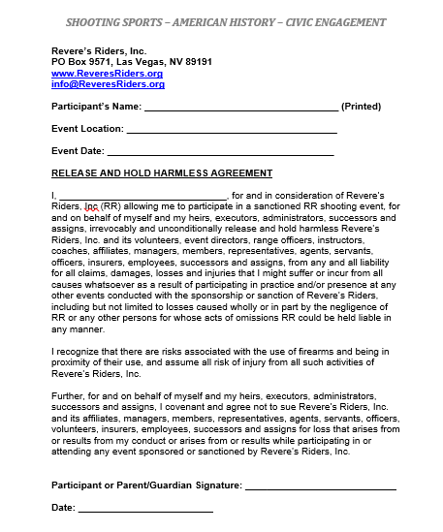***A program of…***

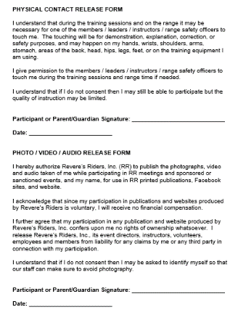**Revere’s Riders, Inc.  
PO Box 9571, Las Vegas, NV 89191**

**www.ReveresRiders.org**

**Location: ________________________**

**Date: ________________________**

T**he undersigned have read, understood, and agree to the RR, Inc “Release and Hold Harmless Agreement,” “Physical Contact Release Form,” and “Photo/Video/ Audio Release Form” pictured to the left. Full-size copies of these agreements and forms have been made available for review. *Individual forms for equipment loans must be completed if applicable.***

*Next to “participant,” legibly write the name of the participant. Each participant must also sign; a parent or guardian must sign for each minor under the age of 18.*

|  |  |
| --- | --- |
| **Participant: ______________________**  **Signature: ______________________** | **Participant: ______________________**  **Signature: ______________________** |
| **Participant: ______________________**  **Signature: ______________________** | **Participant: ______________________**  **Signature: ______________________** |
| **Participant: ______________________**  **Signature: ______________________** | **Participant: ______________________**  **Signature: ______________________** |
| **Participant: ______________________**  **Signature: ______________________** | **Participant: ______________________**  **Signature: ______________________** |
| **Participant: ______________________**  **Signature: ______________________** | **Participant: ______________________**  **Signature: ______________________** |
| **Participant: ______________________**  **Signature: ______________________** | **Participant: ______________________**  **Signature: ______________________** |