This guide will help you collect and enter the information to make a range “official” for hosting Revere’s Marksmen events.

First, log in to the “members only” section of the Revere’s Riders website. Go to <http://www.hitscount.org/> , hover over the “About Us” text in the banner and select the “Membership Information” link. Go to the bottom of the page under “Member Resources” and click the text that says, “click here.” Enter the username and password when prompted.

Go to the bottom of the “Members Only Section” page under “Useful Links” and select “Range Signup Form.”

You should see this:

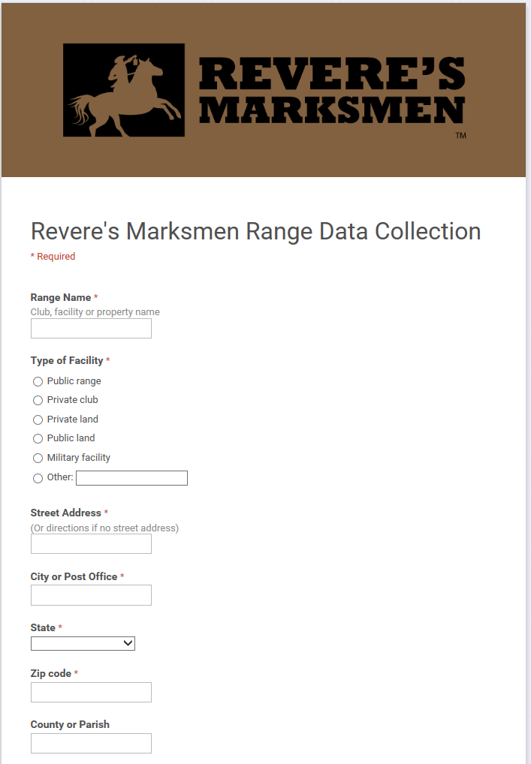

Enter the name of the venue. For example: Bedford Contingent or Hoosier Hills Rifle and Pistol Club.

Is this a public or private venue and is it a range or just someone’s land that they are allowing us to use?

Next, enter the address of the venue.

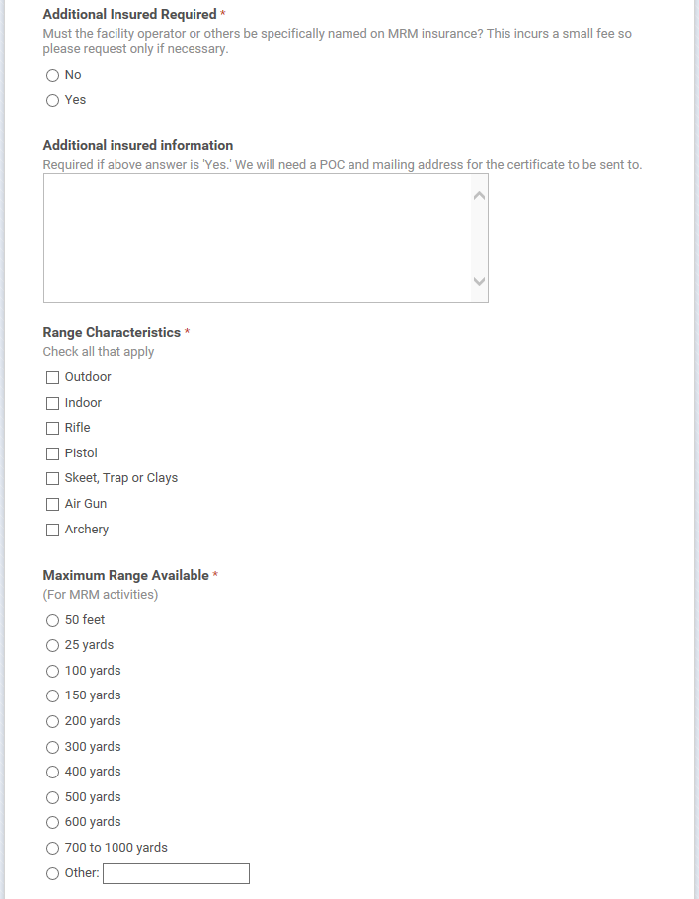

Some range owners like to have a copy of the insurance certificate with their information on it. Doing this incurs an expense so don’t do it if the range owner doesn’t ask for it. However, if doing this makes the range owner happy and he will let us keep coming back, then mark the “yes” bubble. The range owner is covered whether or not he gets a copy of the certificate. Enter the name and mailing address of the person who is to receive the insurance certificate, if requested.

Check all applicable characteristics of the range and activities that can be conducted there that apply.

Next, select the maximum range that can be used for Revere’s Marksmen activities.

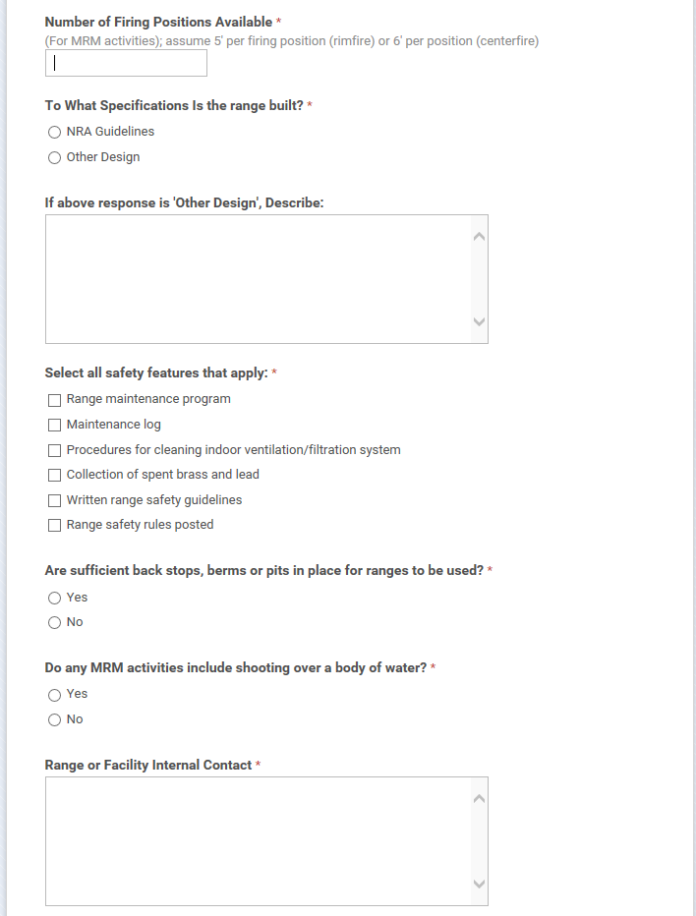

How many people can we get on the firing line? Assume 5 feet per position for rimfire shooting or 6 feet for centerfire.

Was this range built to NRA specs or something else? If no formal specification was used you can say something like, “Bean field repurposed to shooting range.” It’s worked in the past. Something like, “Old playground next to school for blind children” will cause problems.

Go down the list and select all safety features that the range has.

This place you want to shoot at does have backstops and berms, right? Select “Yes,” if so.

Select the appropriate bubble for the issue of shooting over water.

Give us a name and contact information for someone at the range. The range owner or manager would be good.

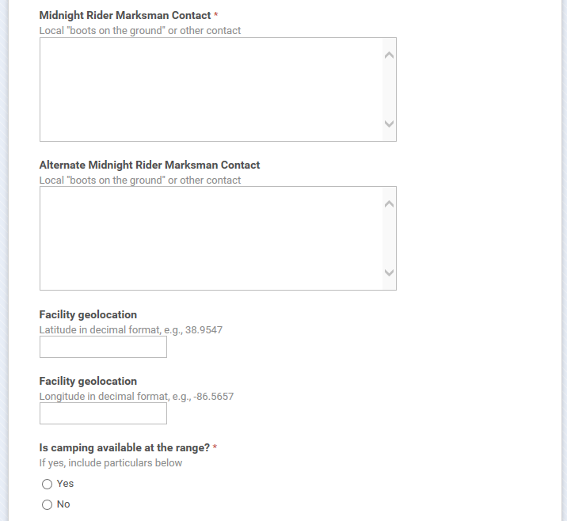

Next, give the name and contact information for the Revere’s Riders/Revere’s Marksmen Boots on the Ground for this range. While you are at it, give us another RR/RM person who can get in touch with the range owner and make things happen.

In the next two fields you enter the GPS coordinates to get participants to the venue. Give the coordinates to the foot of the driveway (or similar location) versus the firing line. We’re trying to get the people there not show them exactly where the firing line is. I use this website for coordinates:

<http://www.findlatitudeandlongitude.com/> Remember to use decimal (and + and -) rather than degrees, minutes and seconds (and E/W and N/S).

Is there on-site camping? If there is then give some details in the next box such as, “Pit toilet, no running water.” Or maybe, “Glamping at its finest with air-conditioned bungalows, silk-lined sleeping bags and turn-down service.”

Also in that box you can put anything else that is important to know about this range such as hour restrictions (no live fire before noon on Sunday out of respect for the church next door) or ammo restrictions (.22 only or no steel core ammo, for example).

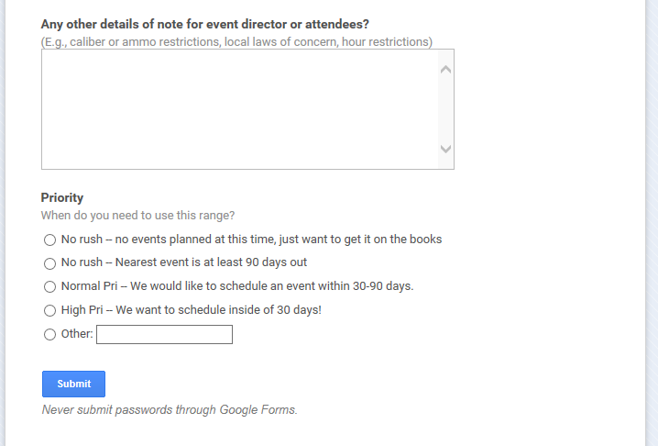

Lastly, how soon does this need to be added to the books? Select the appropriate response and click “Submit”

Postscript -- I have described the Range Signup Form as it is on the 15th of September, 2015. “Midnight Rider Marksmen” and “MRM” are in use on this form. Eventually, I believe this will be changed.

brianheeter