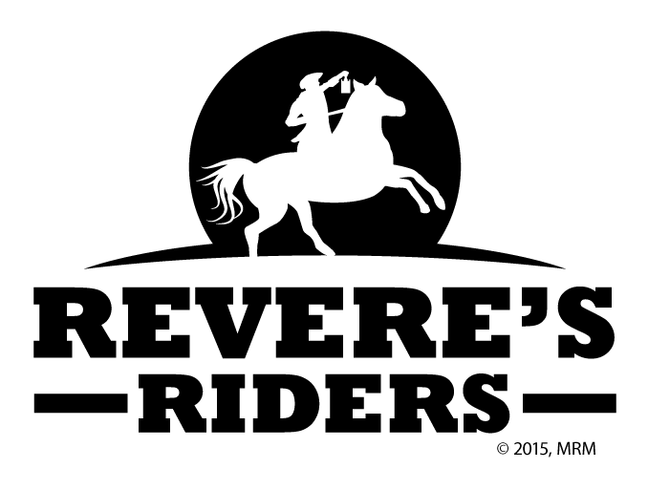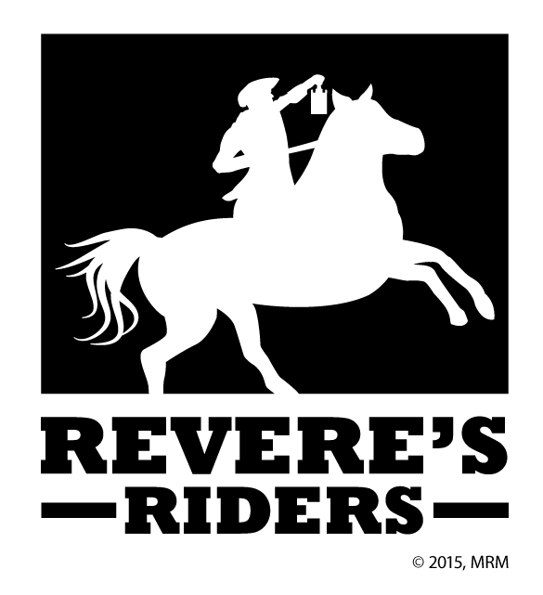

**Shooting Sports**

**American History**

**Civic Engagement**

[Insert Dates for Events Here]

Welcome

#### EVENTS NEAR YOU:

2015

[Recipient]

Address Line 1  
Address Line 2  
Address Line 3  
Address Line 4

[Street Address]  
[City], [State][Postal Code]

Lorem & Ipsum

LIKE NOTHING YOU HAVE EXPERIENCED BEFORE

Challenge yourself at marksmanship events scaled for a variety of skill levels. Rifle and Pistol instruction are available.

Be a part of a better future for all Americans. Learn old skills, inherited history, and take up the challenge of our future.

##### A Dawn Worth Riding For

Make a difference in your community through the body politic as The Founding Fathers intended.

Listen my children and you shall hear, of the midnight ride of Paul Revere... But you've never heard it told like this!

##### American History

##### The Past, Present, And Future

“Revere’s Riders” is a 501c3 volunteer organization dedicated to the shooting sports, American history, and modern civic engagement, all in a grass-roots effort to build a better future for all Americans, those living today as well as those to come. Our tiered courses in marksmanship are set to bring critical safety and mastery instruction to students of all skill levels. Our “Messenger” history presentations are spellbinding experiences that will bring the events at the origin of our nation alive in a way that few experience today. We are dedicated to creating actual change, and seek to motivate students towards political and community action.

##### Civic Engagement

##### Shooting Sports